 | 5th In Flanders’ Fields Rally  “WW I Armistice Centenary Edition”  from Friday, May 11th to Sunday, May 13th 2018 | 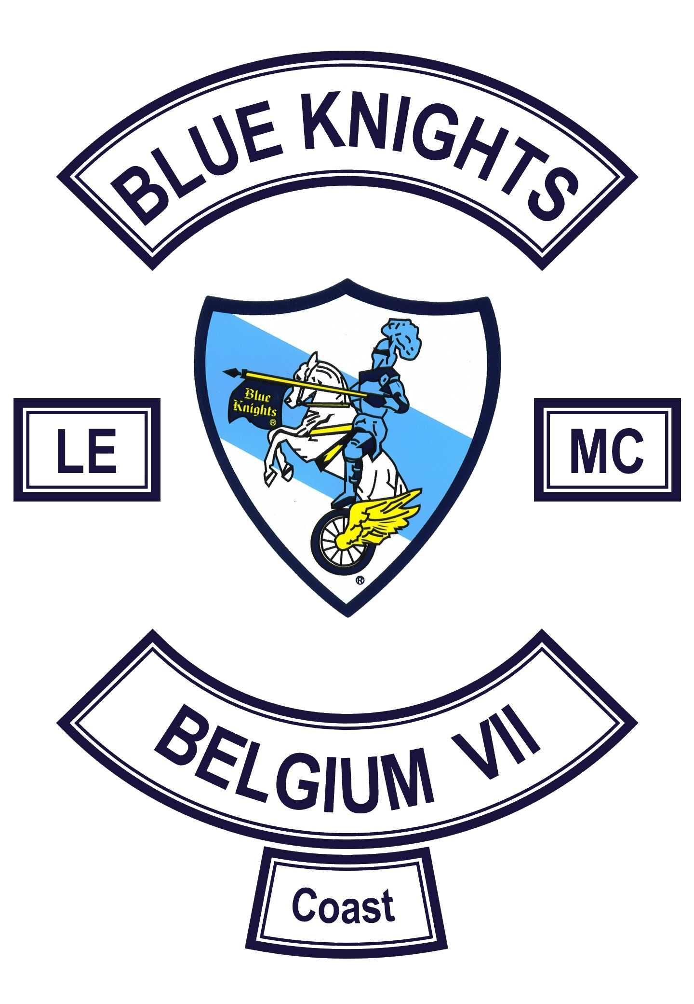

REGISTRATION FORM

Name : | - | First name :

E-mail : | - | Cellphone :

Blue Knights - Chapter : | - | Other :

Motorcycle : | - | License plate :

PARTICIPATION & ACCOMODATION

Mark the chosen formula with an " X "

Overnight(s) | from Fr, 11 to So, 13-05-2018 |  | from Sa, 12 to So, 13-05-2018
Studio’s (for 6 pers., 4 pers. or 4 pers. - disabled) | = 110,- € |  | = 80,- €
Camping (only mobile homes - no tents) | = 80,- € |  | = 60,- €
No overnight(s) | (Fr & Sa) = 60,- € |  | (just Sa) = 40,- €

OTHER PARTICIPANTS

Enter the name of people you want to share a studio with !

Name | First name | Chapter

NOTE : each of these participants has to fill out a registration form as well !

MEALS & ALLERGIES

- Vegan food | - | - Vegetarian food | - | - Halal food

I am allergic to :

T-SHIRT (= 15,- Euro)

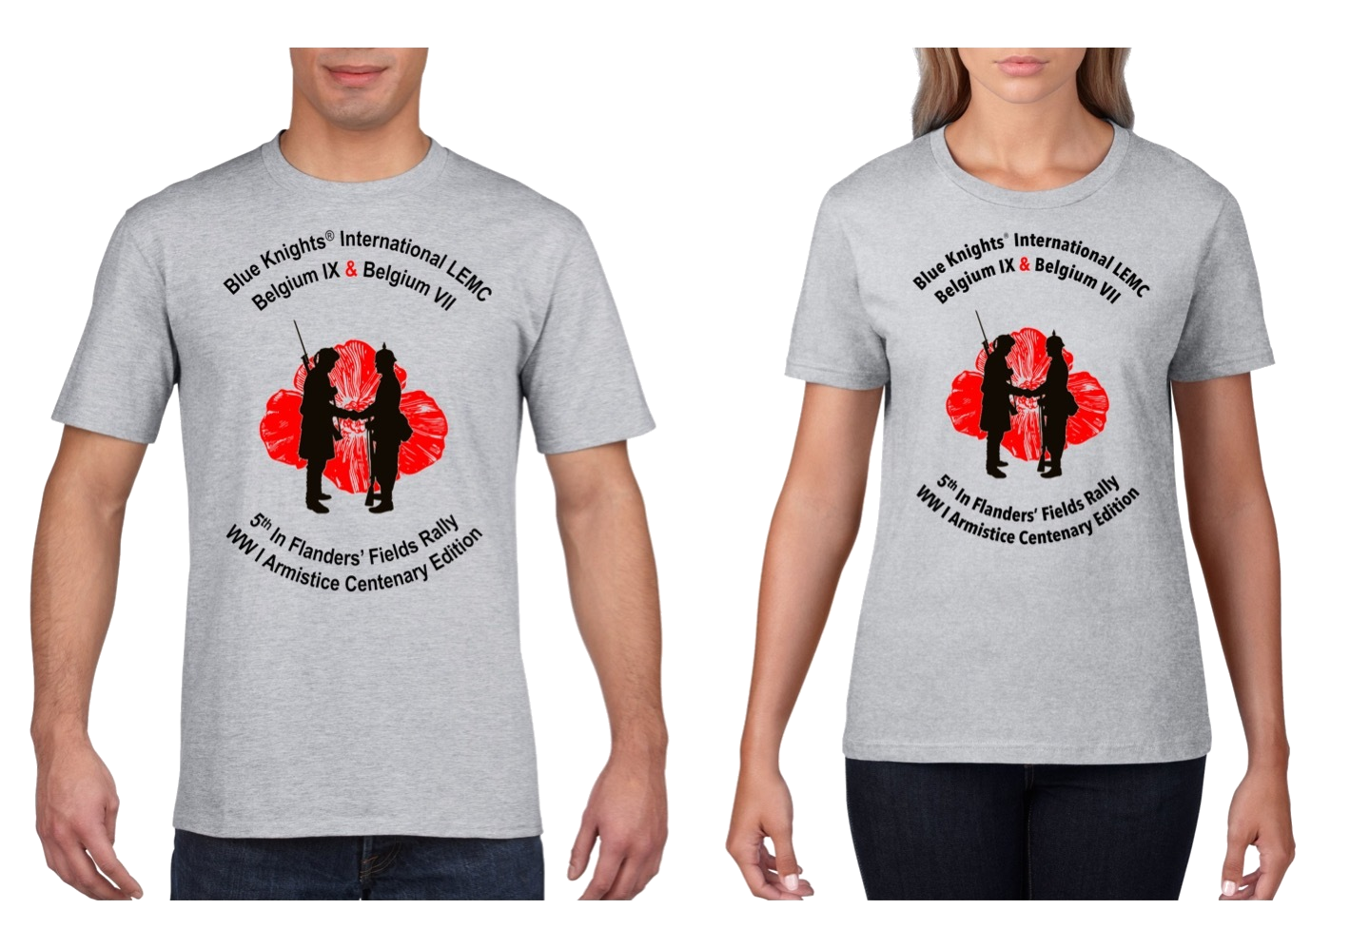 | - I order a T-shirt  my size : | 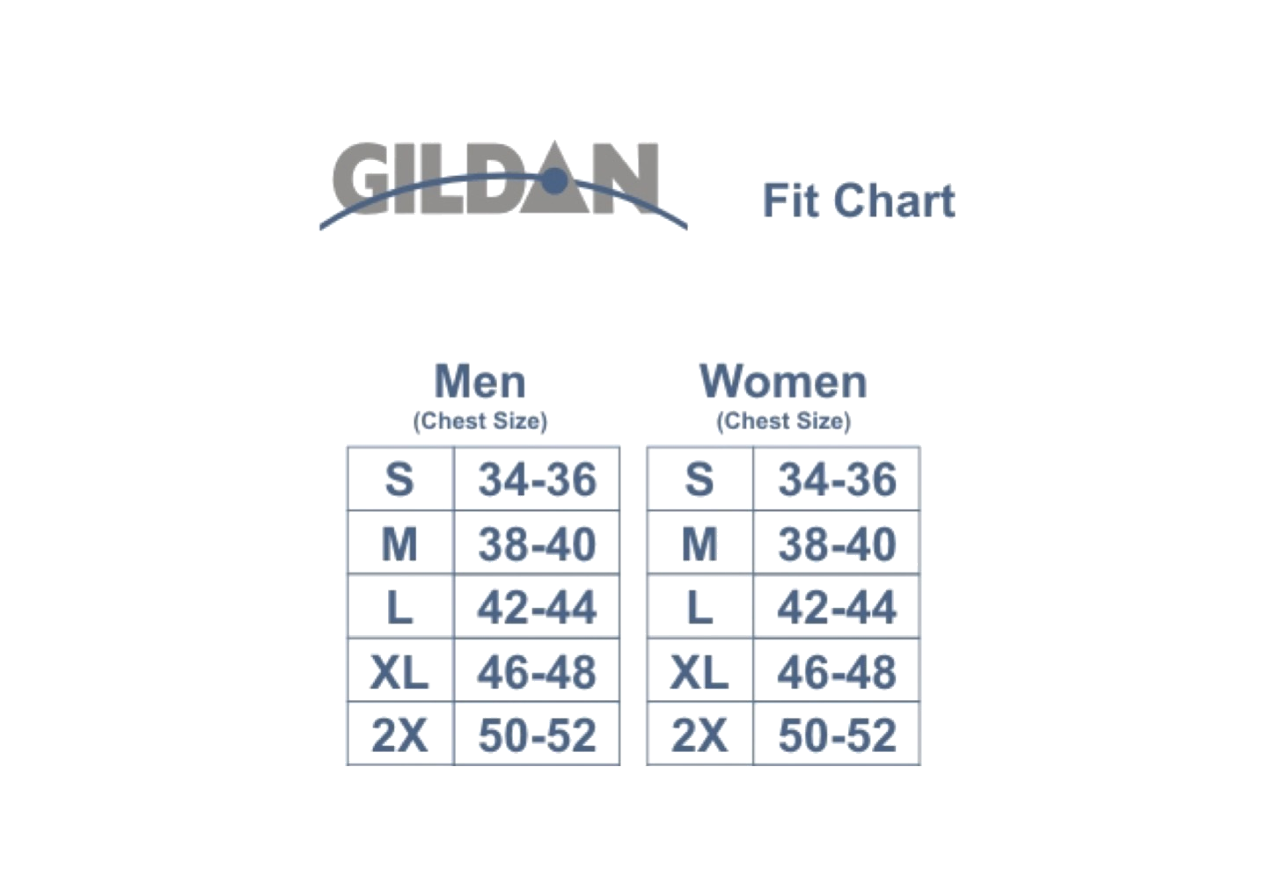

NOTE : T-shirts are only available in European sizes !

BANK DETAILS BLUE KNIGHTS BELGIUM IX

BIC : KREDBEBB | - | IBAN : BE74 7380 1440 3007

NOTES

- The registration forms can ONLY be submitted by E-mail !

- Fill out the registration form, save the document and send it to “ in.flanders.fields.rally@gmail.com “.

- Once we have received the registration fee, we will send you the confirmation of your reservation.

